

Next Generation
Transit Service Operators – Crucial Appointment Ride Service (CARS)

Request for Qualifications

July X, 2026

SOUTHWEST REGION PLANNING COMMISSION
37 Ashuelot Street | Keene, NH 03431 | (603) 357-0557 | www.swrpc.org

Table of Contents
Table of Contents 2
1 Introduction 3
2 About SWRPC and MRCC 4
3 Project Background 5
4 Scope of Services 6
5 Funding Strategy 6
6 Goals 7
7 RfQ Process & Proposed Schedule 8
8 Procedures 9
8.1 Submission Requirements 9
8.2 Submission Procedures 11
8.3 Selection Process 11

Introduction

The Southwest Region Planning Commission (SWRPC), on behalf of the Monadnock Regional Coordinating Council for Community Transportation (MRCC), is seeking qualified transit service providers to assist in the operation of a Next Generation Transit Service (NextGen) for the Monadnock Region of New Hampshire with a target date to begin service by July 1, 2027. The NextGen Project seeks to establish two separate but coordinated public transit services: the Greater Keene Service (GKS) will provide weekday public transit services to the Greater Keene area (the urbanized parts of Keene, Swanzey and Marlborough) and the CARS Crucial Appointment Ride Service (CARS) will provide transit services as backup for existing volunteer driver programs across MRCC’s entire jurisdiction—a 33-town area that includes all of Cheshire County and 10 towns in western Hillsborough County (see Map 1 below). Two separate Requests for Qualification (RfQ) opportunities—one for each service--have been released by SWRPC. This RfQ is for applicants interested in the CARS opportunity. The GKS RfQ opportunity, now closed, is available to review at https://www.swrpc.org/about/jobs-rfps/. Applicants who have already responded to the GKS RfQ may respond to this RfQ as well if interested.

Map 1: Proposed Transit Service Coverage Areas
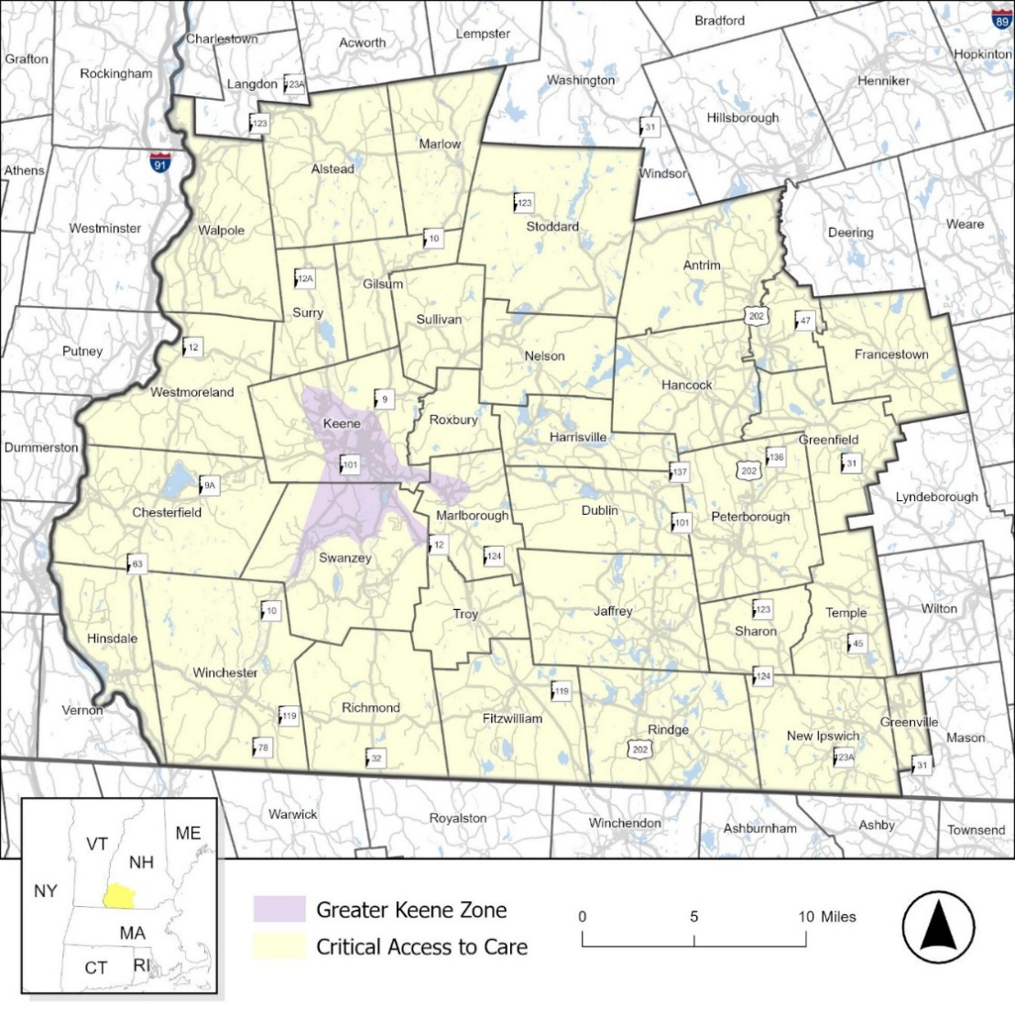

The goal of the NextGen Project is to address key gaps in transit service in the Monadnock Region, focusing on the biggest priorities with the greatest probability of success as determined by several stakeholder-informed local and regional plans. While MRCC seeks to address other gaps across the Monadnock Region over the long-term, in the near-term it is focusing on smaller expansion projects.

The objective of CARS is to provide backup community transportation services for MRCC-affiliated volunteer driver programs (VDPs) with an emphasis on providing individuals rides to critical medical and health services. At the time of writing, MRCC-affiliated VDPs include Community Volunteer Transportation Company and the Keene Senior Center’s Cheshire Village at Home Program. CARS’ role as a backup to VDPs is important to emphasize. VDPs are typically the most cost-effective approach to providing community transportation services. MRCC’s goal is to continue to promote these highly successful programs, which many area residents have come to depend on. Applicants responding to this RfQ are responding to an MRCC initiative to identify one or more preferred partners to operate the CARS program.

While extremely successful, several years of VDP data suggest that up to 10% of eligible ride requests have not been successfully matched with a volunteer driver due to a lack of volunteer availability. The CARS program intends to provide a backup option for individuals that fall into this category of “unmet need” rides, placing a special emphasis on assisting individuals needing to access critical medical or health-related services. Critical health and medical services, as defined in this RfQ, include appointments for treatments, therapies, procedures and surgeries that are critical to the individual’s health and well-being. Examples could include but are not limited to dialysis treatments, cancer treatment, scheduled surgeries and appointments to healthcare specialists. CARS is not intended to provide rides for urgent or emergency care needs.

MRCC receives and allocates Federal Transit Administration (FTA) Section 5310 funding to transportation provider partners, some of which it intends to use as seed funding for CARS. However, to meet anticipated demand, other funding is being pursued by SWRPC and MRCC. Some CARS expansion funding is currently under active consideration by funders, while other funding opportunities have been identified and not yet acted upon. Depending on fundraising success and other limiting factors, the target start date of July 1, 2027 may require an initial launch of a service that is limited by eligibility criteria yet to be determined, however, the goal is to expand access when expansion funding is in place.

About SWRPC, MRCC, and the CARS Steering Committee

SWRPC is one of New Hampshire's nine regional planning agencies established by NH RSA 36. SWRPC covers a planning district consisting of 34 municipalities (~1,000 square miles and ~100,000 people), comprising the Southwest Region of the State, also known as the Monadnock Region. SWRPC’s footprint largely aligns with the Community Transportation Region served by the NextGen Project, with the addition of Langdon and Windsor and the exclusion of Francestown. A primary responsibility of SWRPC is to represent member communities on issues which have a larger-than-local focus as well as issues that require proficiency in planning-related topics in which member municipalities may lack familiarity and/or capacity. For example, SWRPC assists municipalities in drafting transportation-related policies and plans, provides mobility management services on behalf of MRCC to improve coordination of community transportation services regionally, and provides limited planning-level services to area transit agencies. SWRPC also has an ongoing contractual relationship with the New Hampshire Department of Transportation (NHDOT), helping the State plan for and implement transportation improvements in the Monadnock Region. For this project, SWRPC will serve as the primary point of contact for the transit service providers responding to the NextGen Transit Operator Request for Qualifications (RfQ) – Crucial Appointment Ride Service (CARS) opportunity. SWRPC will be supported by MRCC and local, regional and state partners in reviewing and assessing all statements of qualifications responding to this opportunity through the CARS Steering Committee.

MRCC is one of eight regional coordinating councils (RCCs) in New Hampshire and was established by NH RSA 239-B. MRCC covers a 33-town region, previously shown in Map 1 and described in the introduction. MRCC membership includes community transportation stakeholders including transportation providers, human services agencies, and lived experience users of community transportation services. RCCs help coordinate and improve community and public transportation services, typically focusing on creating accessible, affordable transportation options for seniors, veterans, individuals with disabilities, low-income residents and youth. With assistance from the Lead Agency (Cheshire County) and Regional Mobility Manager (via contract with SWRPC), MRCC manages, facilitates and coordinates community transportation services in the region using Federal Transit Administration (FTA) Section 5310 funding. For the NextGen Project, MRCC intends to apply for additional sources of community transportation funding and oversee the use of those funds by negotiating with operators to provide NextGen Project transit services including CARS. Following the RfQ process, MRCC will negotiate with top candidates to identify one or more preferred partners and then will collaborate with the preferred partners to submit applications for funding.

The CARS Steering Committee is an advisory committee to MRCC composed of community transportation stakeholder representatives from the Monadnock Region representing VDPs, hospitals, and major institutions likely to drive a substantial portion of ridership for CARS. The Committee also includes representation from MRCC and ex-officio representation from NHDOT. SWRPC provides facilitation and technical assistance on behalf of the Committee. The Steering Committee’s role is to 1) conduct a due diligence assessment of prospective operators, 2) rank and distill the field of applicants to top candidates based on a pre-defined scoring rubric and interviewing process, and 3) make an endorsement and recommendations on preferred partner operator candidates that MRCC should work with to refine a CARS scope of services necessary for applications to the Federal Transit Administration for Section 5310 and other sources of funding (See Section 5: Funding Strategy for more information).

Project Background

Based on several years of planning and public involvement activities, the RfQ aims to identify operators interested in implementing CARS. The CARS program proposal stems from planning and public involvement activities that were facilitated by SWRPC, on behalf of the MRCC, with support from a stakeholder Advisory Task Force and the assistance of private transit consulting firms. The first stage of planning work and public involvement, conducted between July 2021 and June 2023, involved an assessment of existing community transportation services and gaps in needed services. It culminated in a report produced by SWRPC called Opportunities for Expanding Volunteer Driver Program Categories and Addressing Unmet Need which was published in June 2023. A second stage of work was conducted with the assistance of transit consulting firm Steadman Hill Consulting between July 2023 and June 2024. It involved additional work putting together an implementation framework for the first phase of the NextGen Project’s implementation, including the development of goals, an evaluation of various models of transit service delivery, and the development of an Implementation Plan (Steadman Hill Consulting Implementation Plan).

SWRPC recently reengaged Steadman Hill Consulting, Inc. (SHC) as an on-call transit consultant to assist with the launch of the NextGen Project from March 2026 through June 2027. SHC will play a support role in evaluating potential CARS transit operators and providing support to MRCC and the selected operator(s) to prepare for launch. Transit consultant services available will include facilitating maintenance and operations planning, software and hardware research and procurement, governance and policy technical assistance, outreach, education and public relations assistance, and other miscellaneous needs.

4 Scope of Services

As noted in the introduction, the proposed CARS program will address many of the “unmet need” rides that existing MRCC-affiliated volunteer driver programs are unable to accommodate due to the lack of volunteer drivers. Typical reasons for volunteer driver unavailability may include the time of day of the request or the geographical location of the ride. As noted earlier, up to 10% of MRCC-affiliated volunteer driver program rides are unmet due to driver unavailability. Over the past three fiscal years, this has ranged from x to y number of rides. Most of these ride requests are for medical or health services.

The intent of the CARS program will be for volunteer driver programs to refer rides to the selected transportation providers on a rolling and as-needed basis. It is anticipated that CARS transportation providers will have 48-hour notice ahead of the requested ride time, similar to the timeframe given to NH-based Medicaid transportation providers. Vendors are expected to utilize their own vehicle fleet, and drivers and vehicles will be required to meet applicable state and federal requirements including insurance coverage at a minimum of $250,000 per person and $500,000 per incident. Some rides will need wheelchair access vehicles. Service delivery will be curb to curb. Some long-distance trips to the Veterans Administration Medical Center in White River Junction, VT, Dartmouth Hitchcock Medical Center, Lebanon, specialists in Metro Boston and other tri-state locations (NH-VT-MA) are anticipated to make up a portion of ride requests. Base eligibility for rides will be restricted to riders needing a ride to or from the 33-town MRCC district shown in Map 1, however, rides that can be met with in the GKS zone will be managed by the GKS service provider(s).

Additional ridership eligibility criteria restrictions are likely to be instituted as part of the program as a way to prioritize rides with limited resources. Eligibility restrictions will depend in large part on the success in raising additional funds to expand services and will be set and updated by MRCC in consultation with volunteer driver programs and CARS vendors.

Desired Expertise and Capabilities

- Wheelchair Securement and Mobility Device Safety
Demonstrate competency in wheelchair securement through recognized industry training programs such as:
• Community Transportation Association of America (CTAA) PASS Program
• Non-Emergency Medical Transportation Accreditation Commission (NEMTAC) training standards
Providers should maintain policies regarding mobility device securement, occupant restraint systems, and vehicle accessibility consistent with current ADA and industry best practices.

- Redundant Communications and Emergency Response Capability
Providers should maintain redundant communication systems capable of supporting operational continuity and preparation for requesting urgent assistance in emergent situations.
Examples may include:
• Cellular communications
• Two-way radio communications
• GPS vehicle monitoring
• Emergency dispatch notification capabilities

- Recognition of Increasing Passenger Assistance Needs
Providers should have the capability to safely provide varying levels of assistance, including:
• Curb-to-curb service
• Door-to-door service
• Hand-to-hand assistance when appropriate
Providers should also maintain training regarding passenger assistance, fall prevention, dementia awareness, and transportation of individuals with cognitive impairments.

- Medical Appointment Reliability Standards
Providers should have experience in reporting on performance expectations regarding:
• On-time performance
• Trip completion rates
• Missed trip reporting
• Complaint resolution processes

- Driver Training Requirements
In addition to standard licensing and insurance requirements, providers should demonstrate training programs related to:
• Passenger assistance techniques
• Wheelchair securement
• Defensive driving
• Dementia and cognitive impairment awareness
• Customer service and de-escalation
• Emergency procedures

- Coordination with Healthcare Facilities and Volunteer Driver Programs
Experience in establishing referral pathways and communication protocols with:
• Volunteer Driver Programs
• Healthcare facilities
• Transportation providers
• Regional mobility management staff

- Rural Service Area Considerations
Ability to service destinations extending to White River Junction, VT, Dartmouth Hitchcock Medical Center, Lebanon, specialists in Metro Boston and other tri-state locations (NH-VT-MA)

Funding Strategy

With assistance from Steadman Hill Consulting, SWRPC has identified an estimated budget, funding sources, and resources to implement CARS starting in July 2027. The base budget for CARS services is anticipated to be $x.00, and the current budget goal for expanded services is $200,000 per year. This budget can be used to advance many of the CARS objectives starting in July 2027. In the meantime, the number one goal of SWRPC and MRCC is to identify and secure additional sustainable funding sources to support the CARS Program’s aspirational scope of services.

FTA Section 5310 funds will be available barring a major change to federal policy. SWRPC has assurances from the NH Department of Transportation (NHDOT), which directs the flow of these funding sources around the State of New Hampshire, that it intends to continue to invest 5310 funds into Regional Coordination Councils. SWRPC’s partner, MRCC, similarly provides assurances that it intends to direct certainSection 5310 funding towards the NextGen Project including CARS. The next funding cycles for 5310 funding starts July 1, 2027, in sync with the proposed CARS start date.

SWRPC and MRCC have also been pursuing additional CARS funding. SWRPC and MRCC are positioned to apply for New Hampshire’s “GO-NORTH” initiative, which has transportation funding associated with the federal Rural Health Transformation Program. Other federal and private funding sources have been identified and are being pursued as grant cycles open.

Outside of the funding sources noted above, the NextGen Project will rely on local funding. Securing local funding commitments for the NextGen Project is one of SWRPC’s and MRCC’s top priorities. SWRPC and the MRCC mobility manager have met with and are committed to continuing to meet with prospective funding partners to support the NextGen Project. SWRPC and MRCC are also meeting with institutions in the area that provide limited transportation services to their clients, collaborating with them to consider redirecting and pooling their investments into the NextGen Project.

Goals

As noted in Section 3, the NextGen Project has already been through a process of developing an implementation plan. As part of the process, SWRPC worked with Steadman Hill Consulting and an Advisory Task Force to develop several goals to guide implementation. Three of the goals, discussed briefly in this section, focus on qualities that are expected of candidate GKS operators.

Regional perspective: The first goal is to find transportation providers that are sincerely committed to the NextGen Project vision of expanding transit services regionally where feasible and when practical over the long term. As such, transit providers should be open to the idea of growing their own services over time and/or open to working collaboratively and cooperatively with other providers that are suitably equipped to expand services in the Monadnock Region. This will require an openness to periodically consider requests for extensions or expansions of existing services by MRCC, as well as exhibiting good faith in cooperating with them to evaluate the feasibility of expansion proposals.

Representative governance: A second important goal of the NextGen Project is to secure transportation providers that embrace open and communicative relationships with the riding public and fiscal partners (i.e. the customers). Going into the NextGen Project, the ideal transit providers will be committed to accountability and transparency as well as an openness for customers to provide feedback to improve service delivery. This may be achieved through commitments to advisory groups, periodic stakeholder meetings, shared operations data, reports on customer requested performance metrics, participating on the MRCC, and/or other means.

Maximize flexibility: The final key goal is to find transportation providers that have the capacity and are open to making small adjustments or even major changes when there is strong evidence that the proposed change will improve service delivery, especially if the proposed change is measured against customer- and provider- agreed service delivery objectives. Providers interested in CARS may need to be open to adjusting rider eligibility requirements based on the types of rides being requested, the relative demand for those types of rides, and the available budget for providing services. Similarly, the budget may change eligibility for long distance medical rides if demand is higher than anticipated.

RfQ Process & Proposed Schedule

The purpose of this RfQ is to help SWRPC and the CARS Steering Committee conduct due diligence on the field of candidate transit operators interested in playing a role in the implementation and delivery of transit services for the NextGen Project. Top candidates emerging from the RfQ process will be recommended to MRCC following the RfQ process for further negotiations, selection and collaboration on forthcoming grant applications. Top applicants may be required to submit a service proposal to facilitate the negotiation process.

The process begins by releasing the RfQ on July X, 2026. Applicants will have until 5 p.m. EST on July X, 2026 to submit questions in writing about the RfQ opportunity. Questions must be submitted by email to jbmack@swrpc.org. Submitting questions is not mandatory. SWRPC will respond to questions and post them on the SWRPC webpage at www.swrpc.org/about/jobs-rfps/ by 5 p.m. EST on July X, 2026. Interested parties should keep questions to a minimum and focus on questions that will assist the applicants in adequately responding to the RfQ. Note that applicants will be given the opportunity to submit questions that are not directly related to the RfQ process as part of the Statement of Interest and Qualifications described in Section 8.1. While the CARS Steering Committee commits to answering all questions in good faith, it reserves the right to decline providing responses to questions that it considers irrelevant to the task of responding to the RfQ, questions that are premature and better suited for discussion with applicants during the negotiation process, or questions to which the Committee doesn’t have adequate information to respond.

Following the question-and-answer period, interested parties must submit a Statement of Interest and Qualifications by 5 p.m. EST on July X, 2026 by email to jbmack@swrpc.org. Additional details about the Statement of Interest and Qualifications follow below.

Upon receipt of the Statements of Interest and Qualifications, SWRPC and the CARS Steering Committee will review and screen the submissions for compatibility with CARS and schedule interviews with the highest-ranking candidates. The Committee reserves the right to select or decline any number of candidates for interviews and to follow up and request any additional information from any interviewee after the interview process. Interviews are tentatively scheduled to occur in August, 2026 and may occur virtually, in-person or in hybrid format.

Below is the schedule for the project. Dates followed by an asterisk (*) are firm.

Milestone | Target Date
RfQ Released | July 5, 2026*
Written Questions about RfQ Opportunity Due | July 12, 2026*
Responses to Questions to RfQ Posting Date | July 19, 2026*
Statement of Interest and Qualifications Due | July 26, 2026*
Interview Period | August, 2026t
Top Candidate(s) Recommended for Negotiations with MRCC | September 2026

Procedures

8.1 Submission Requirements

Interested parties must respond to this RfQ opportunity with a Statement of Interest and Qualifications, which is described below.

Statement of Interest and Qualifications

The Statement of Interest and Qualifications must include the following items:

- Information about applicant Provide a brief history of the applicant as it relates to the project and a description of the experience, qualifications and capacity to provide transit services. If the applicant runs multiple services or services have changed over time, please clearly describe and differentiate each service. This section of the Statement of Interest and Qualifications should not exceed 3 pages. At a minimum, this part of the Statement of Interest and Qualifications must include:

- Name of company or organization
- IRS filing status, certificate of good standing (if applicable), and evidence of eligibility to operate in the State of New Hampshire
- Name of Owner, Chief Executive Officer and Chief Operating Officer or equivalent
- Company/organization business address
- Company/organization year of establishment and number of years providing transit or similar services
- Operational description of current transit or similar services including geographic description of transit service delivery area (i.e. routes, zones, territory), hours of operation, number of vehicles and number of drivers.
- Last complete fiscal year of transit or similar service operational data indicating number of rides, revenue miles and revenue hours.
- Description of company/organization vehicles including year, make, model, chassis (if applicable) and current mileage. Indicate if any vehicles provide wheelchair accommodation and maximum # of seats.
- Description of ride request process and dispatch operations if applicable
- Statement of interest in CARS as well as an explanation as to why the company/organization is well positioned to provide the service

- Understanding and questions about the project: Provide a narrative demonstrating the transit provider’s understanding of the project including any provider insights or recommendations as well as any key questions about theCARS Program. This section of the Statement of Interest and Qualifications should not exceed 3 pages. This must include:

- Brief description of the CARS program as the transit provider understands it, and the role the transit provider proposes to provide including any limitations to its participation (e.g. other obligations, capacity limitations, geographic limitations, etc.)
- Statement as to how the transit provider’s company or organization aligns with the three NextGen Project goals outlined in Section 6 of the RfQ
- Other general observations about the CARS Program, including insights or recommendations regarding the CARS Program. This is an opportunity for the transit provider to share thoughts, but it is not mandatory.
- Prioritized list of 10 or fewer questions the transit provider would like to discuss if invited for an interview about the CARS Program

- Resumes for key staff: The proposal must include resumes of key staff that will be involved in the project. Each resume should not exceed two pages.

8.2 Submission Procedures

The submission must include the items detailed under Section 8.1, Submission Requirements. Interested parties must email their submission materials to J. B. Mack at jbmack@swrpc.org. A cover letter no longer than one page long may accompany the Statement of Interest and Qualifications.

Submissions must be received by 5:00 p.m. EST on July 26, 2026. Submissions received after the deadline will not be accepted.

8.3 Selection Process

The CARS Steering Committee will review and rank all Statements of Interest and Qualifications according to the rubric shown below.

Scoring Rubric

1. | The submission meets all requirements outlined in this RfQ. | Yes [ ] | No [ ]
 |  | Points Available | Points Awarded*
2. | The applicant demonstrates strong evidence that the company/organization has experience, qualifications and capacity to provide transit services that will help meet the needs of CARS. | 3
3. | The applicant demonstrates a good understanding of the NextGen Project and the potential role it could play in CARS. | 3
4. | The applicant makes a convincing case that it is currently and will continue to be well aligned with the operator-related goals of CARS. | 3
5. | The applicant offers thoughtful insights or questions that will benefit final planning and implementation of CARS. | 3 | _____
6. | The resumes or other information presented about key staff demonstrate strong relevant experience and training that will benefit the NextGen Project. | 3 | _____
7. | The applicant thoroughly and completely addresses the information requested by the RfQ process and demonstrates strong attention to detail. | 3
8. | Demonstrated capability to manage long-distance medical transportation | 3
9. | Demonstrated capability to operate across state lines when necessary | 3
10. | Demonstrated capability to maintain sufficient staffing and vehicle resources for extended-duration trips | 3
11. | Demonstrated capability to respond to unexpected schedule changes associated with healthcare appointments | 3
 |  | Total

* Points will be awarded as follows: 0 points, scorer does not agree; 1 point, scorer partially agrees; 2 points, scorer agrees; 3 points, scorer strongly agrees.

At its discretion, the CARS Steering Committee will invite operators with the highest scoring Statements of Interest and Qualifications to a round of interviews. Interviewees should include the Chief Executive Officer and Chief Operating Officer or equivalent representative able to speak on behalf of the organization. Scoring rubric criteria 2 through 11 may be updated by each committee member based on the interview. Top candidates emerging from the RfQ process will be invited to negotiate the terms of service for CARS and may be asked to submit a service proposal. SWRPC/MRCC reserves the right to reject any or all Statements of Interest and Qualifications received. SWRPC/MRCC will not reimburse transit providers for any work completed or submitted as part of this process.

Historically, the majority of MRCC’s volunteer driver program rides are for non-emergency medical rides (NEMT). The use of the term NEMT in this case is not referring to Medicaid rides. It is referring to rides that do not require an ambulance and are medically related. Importantly, MRCC volunteer driver programs screen for and refer all ride requests that are Medicaid-eligible directly to NH’s Medicaid brokerage system.

