Concerned about Transportation/Mobility Issues in the Greater Nashua area?
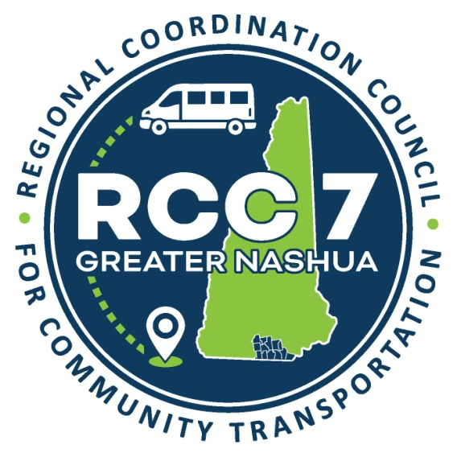
Greater Nashua Regional Coordination Council for Community Transportation Monthly Meeting
Thursday, April 24th 2025 ⁻ 10:00 a.m.


At the Nashua Regional Planning Commission,
30 Temple Street, Suite 310 Nashua, NH 03060, 3rd Floor

Contact person: Donna Marceau, Regional Mobility Manager
Email: donnam@nashuarpc.org to RSVP
Refreshments will be served!

