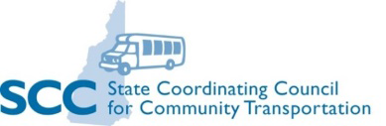  The Greater Nashua Regional Coordination Council (RCC7) is one of eight regional councils serving under the State Coordinating Council for Community Transportation. Together these organizations are striving to develop a sustainable statewide system of coordinated community transportation providing improved local and interregional mobility and access to all.  - 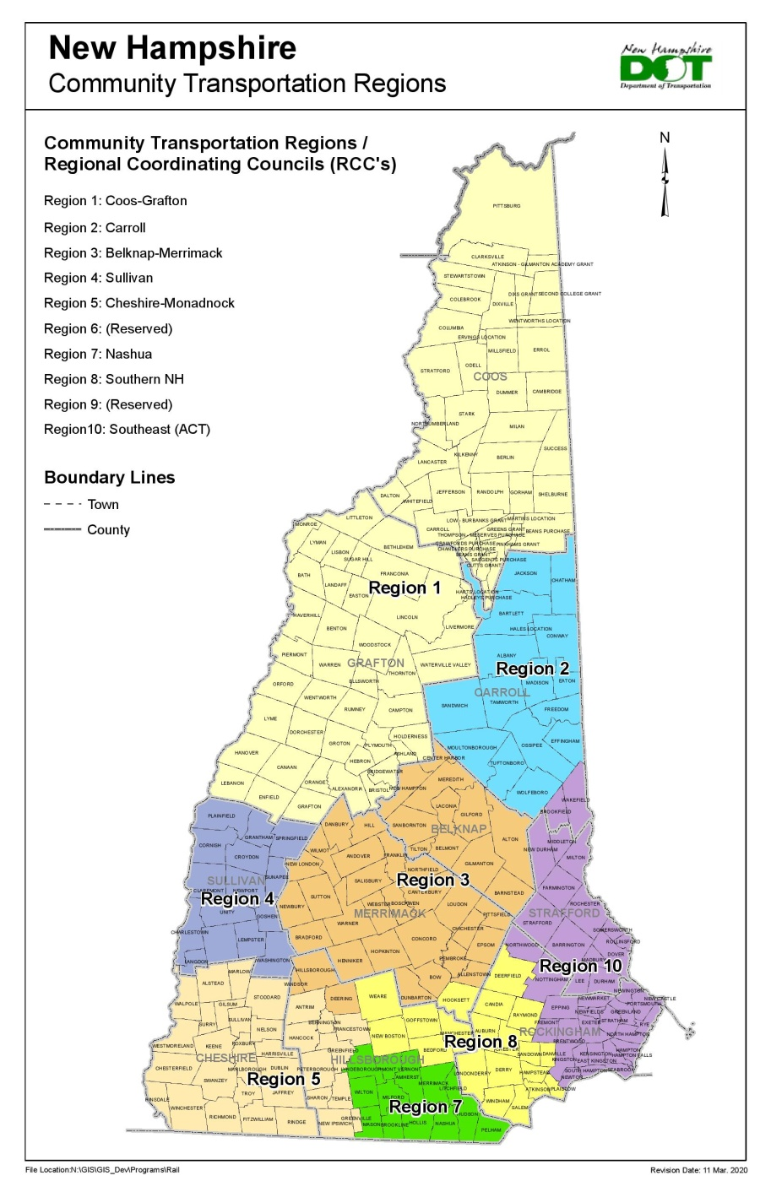 |  |  |  |  |  | 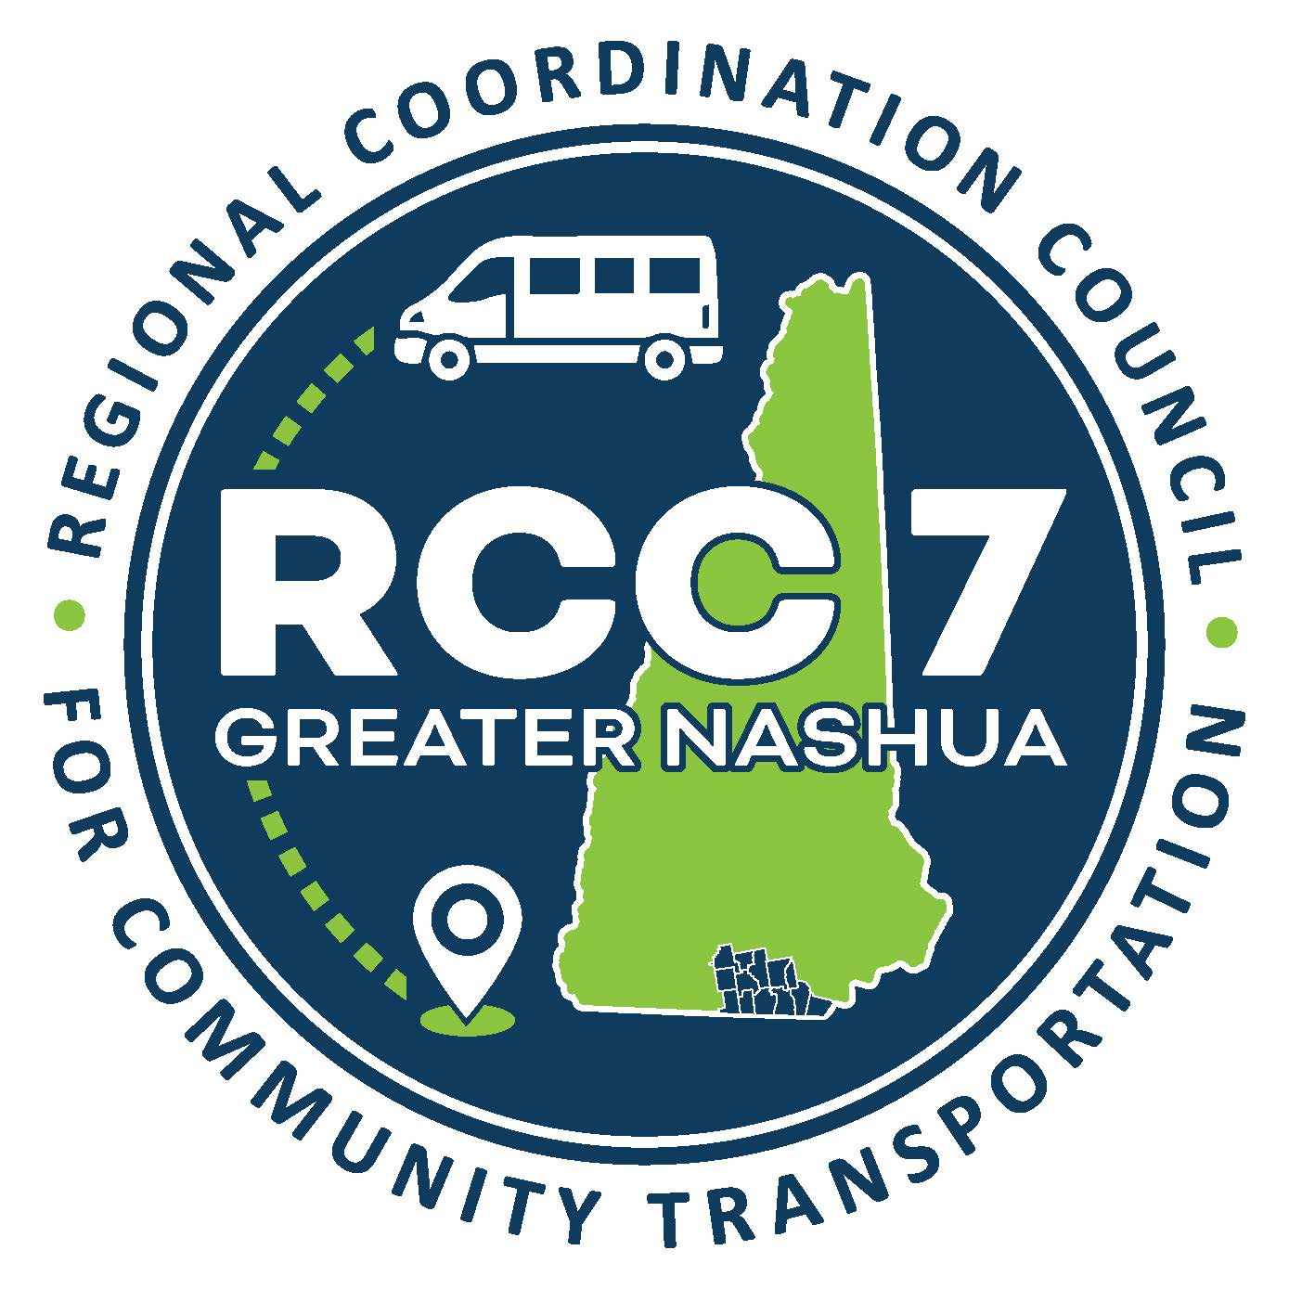  Leveraging the efforts and resources of many different organizations and individuals to work collaboratively on coordinated strategies to improve transportation services for all residents in need of assistance.
  Mobility Management
  The Mobility Management Program is an opportunity to promote a sustainable coordinated customer-centered community transportation that is accessible to all, including older adults, persons with disabilities, veterans, low-income individuals, and other vulnerable populations.
  Please Come Join Us:
  Meetings: the 4th Thursday of the month at 10AM with in-person and online options.
  At the Nashua Regional Planning Commission office
  30 Temple Street, Suite 310
  Nashua, NH 03060
  www.nashuarpc.org
  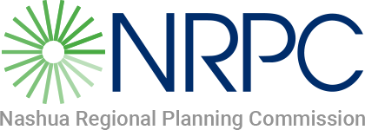
  For more information or transportation assistance, please, contact:
  Donna M. Marceau
  Regional Mobility Manager
  RCC 7
  (603) 417 6571
  donnam@nashuarpc.org
  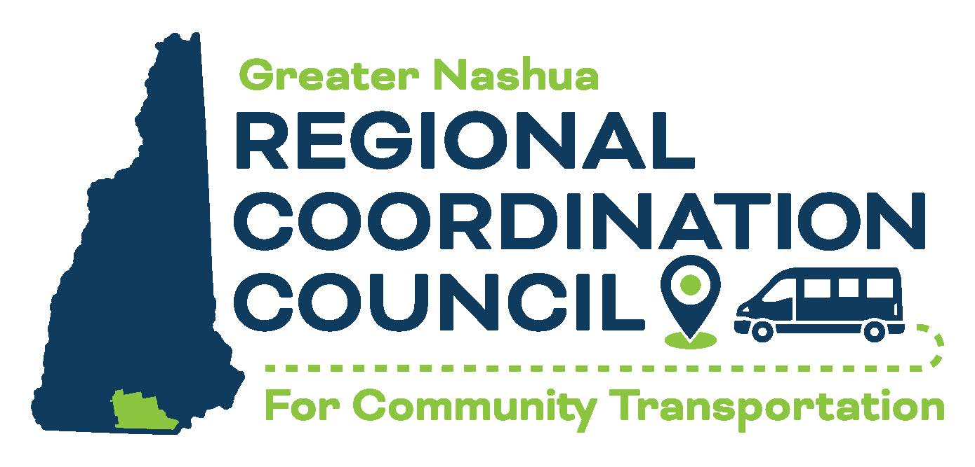
  RCC 7
  Greater Nashua
  Transportation
  Mobility Guide

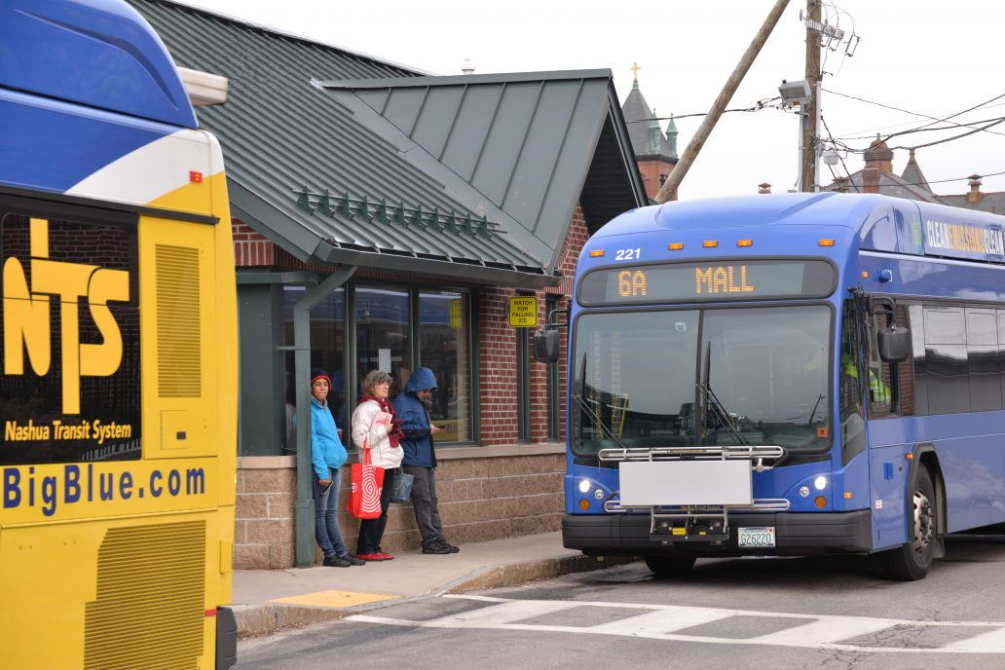  Bus Service  Nashua Transit Service  11 Riverside Street  Nashua, NH 03062  (603) 880 0100  www.RideBigBlue.com  Serving: Nashua, Merrimack, and Hudson  Souhegan Valley Rides  P.O. Box 753  Hollis, NH 03049  Information: (603) 860 1202  Scheduling: (603) 880 0100 x 2  www.SouheganValleyRides.org  Serving: Amherst, Brookline, Hollis, Milford, Mont Vernon, and Wilton  Manchester Transit Authority  110 Elm Street  Manchester, NH 03101  (603) 623 8801  (Nashua Transit Center to Manchester, the airport and NH connections.)  Schedule Info: www.mtabus.org |  |  | Boston Express Bus  Exit 8 – Rte.3 Nashua, NH  (603) 845 1999 www.bostonexpressbus.com  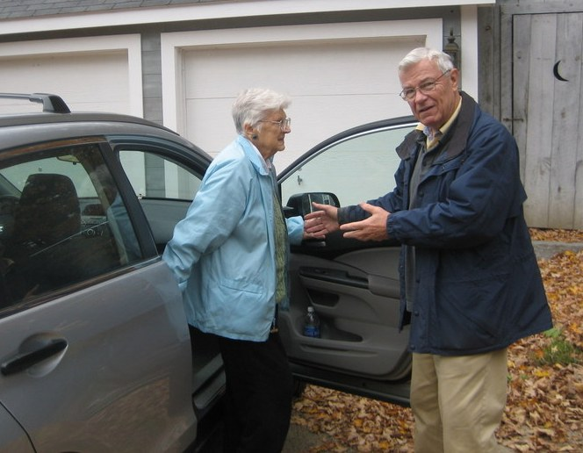Volunteer Driver Programs  The Caregivers ~ Caring Rides  700 East Industrial Park Drive  Manchester, NH 03109  Call: (603) 622 4948  Serving: Greater Manchester area & Amherst, Hollis, Hudson, Litchfield, Merrimack, Milford, and Nashua  CTVC – Community Volunteer Transportation Company  375 Jaffrey Road, Suite 3  Peterborough, NH 03458  Call: (877) 428 2882  Serving: Mason  Greater Salem Caregivers  44 Millville Street  Salem, NH 03079  Call: (603) 898 2850  Serving: Pelham |  |  | 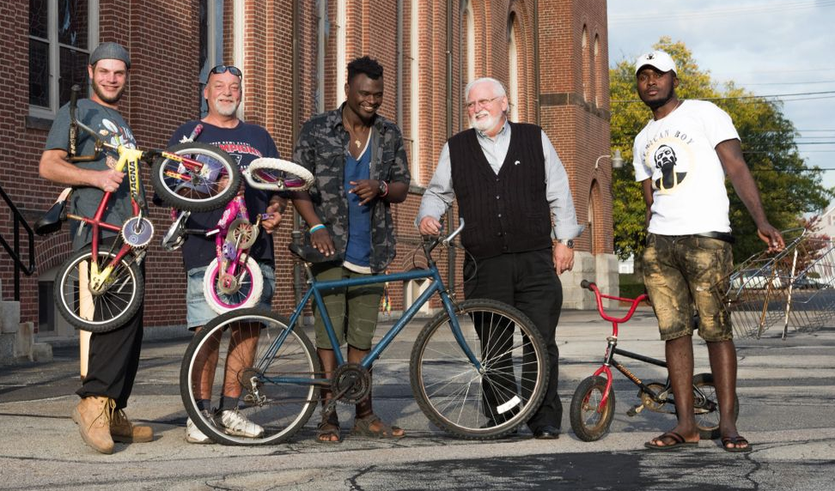  Bicycles  Gate City Bike Coop  No cost bikes for those who are eligible.  www.gatecitybikecoop.org  (603) 759 9056  Taxi Services  Granite State Taxi – (603) 417-6116  Milford Taxi – (603) 672 3344  SK Taxi – (603) 882 5155  Transportation Coalitions  CommuteSmartNH  www.commutesmartnh.org  Volunteer Driver Program Network  www.NHVDP.org  Transport NH  www.TransportNH.org  State Coordinating Council  www.nh.gov/dot/programs/scc  www.keepnhmoving.org  Medicaid Transportation  www.dhhs.nh.gov

