Annual Report For

Fiscal Year 2024, July 1, 2023 – June 30, 2024

Mobility Management in the Regional Coordination Council for Community Transportation of Greater Nashua (RCC7)

Nashua Regional Planning Commission
Metropolitan Planning Organization
30 Temple Street, Suite 310, Nashua, NH 03060
nashuarpc.org

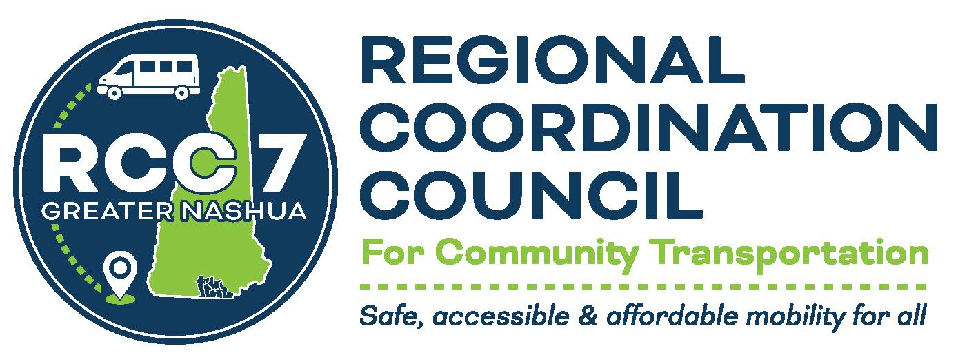

Summary of FY 2024

In its second year of existence at the Nashua Regional Planning Commission, Mobility Management in Greater Nashua completed a successful year reaching out to populations without transport, connecting rides to those seeking help, and closing gaps in the community transportation network in Greater Nashua. FY2024 witnessed an increase in outreach events from 101 in FY2023 to 156 in FY2024, a percentage increase of 54%. These outreach events spurred an increase in requests for help from 136 in FY2023 to 201 in FY2024, a percentage increase of 47%. A significant reduction in the gaps in community transportation occurred with the donation of funds from Saint Mary’s Bank to bridge the wheelchair gap that was occurring in municipalities without access to wheelchair service.

Assistance Requests in FY 2024
These requests for help take the form of telephone calls, emails, responses to random social media posts, and personal encounters with individuals who need transportation assistance. However, most requests for assistance were the results of outreach to various groups, social service agencies, municipalities, senior citizen facilities, and from the Nashua Transit System Mobility Manager, Kerry Miller. Kerry Miller provides excellent assistance to those who utilize the Nashua Transit System. However, due to the high number of service requests, and the irregular nature of some of the requests, the Nashua Transit System cannot handle all calls. Kerry Miller sends calls that cannot be serviced to the Mobility Manager. The statistics for Mobility Management Services for the fiscal year 2024 (July 1, 2023 – June 30, 2024) are as follows:

Total Number of Requests for Service/Information: 201
Types of Requests
All Needs 7
Bike 42
Bus Info 2
Food Shopping 4
Immigrant Needs 2
General Info 6
Loan Info 10
Medical Appointments 82
School 3
Social 14
Work 23
Other 6

Assistance Requests by Municipality:
In contrast to FY2023, FY2024 saw the addition of the residents of Amherst, Brookline, Lyndeborough, and Mont Vernon to those municipalities asking for transportation help.
Amherst 2
Brookline 2
Hudson 8
Litchfield 1
Lyndeborough 1
Merrimack 11
Milford 12
Nashua 139
Pelham 6
Wilton 4
Out of Region 14

Thus, from these statistics, we observe that most requests are from the core center of the NRPC region, the area where residents may lack vehicles. The residents of the City of Nashua, along with the towns of Hudson and Merrimack requested the highest number of transportation services. Many residents expressed gratitude for the Mobility Management services. Apart from wheelchair service in specific municipalities, most requests resulted in access to transportation.

Helping Individuals Afford Transportation Needs - Digital Credit Union’s Axuda Program
The Mobility Manager assisted individuals access a $600 no-interest loan from the Digital Credit Union. The hope is that these funds will be used for transportation needs such as car repair or car purchase. In FY 2024, 10 individuals sought information about the Axuda program.
Lack of Vehicles by Municipality:
Please see the chart below which demonstrates the estimated percentage of zero-vehicle households per town, based on the 2022 American Community Survey (ACS) of the U.S. Census Bureau —the latest ACS available for the ownership of vehicles in each municipality in the Nashua Regional Planning Commission District:

Amherst | 1.97%
Brookline | 1.17%
Hollis | 0.67%
Hudson | 1.30%
Litchfield | 1.68%
Lyndeborough | 0.83%
Mason | 1.28%
Merrimack | 2.01%
Milford | 3.91%
Mont Vernon | 4.32%
Nashua | 7.43%
Pelham | 2.23%
Wilton | 8.36%

Libraries Visited
In FY2024, the Mobility Manager visited libraries in the NRPC region to reach out to those senior citizens who may not visit the senior centers. Libraries in the towns of Amherst, Hollis, Hudson, Merrimack, Milford, Nashua, and Pelham were visited.
Visits to the remaining municipal libraries will be concluded in FY2025.

Locally Coordinated Transportation Plan and the Nashua Transit System Surveys
The Mobility Manager participated along with the NRPC Transportation Team members, Matt Waitkins, MPO Coordinator, and Mary Brundage, Regional Planner in constructing the Locally Coordinated Transportation Plan survey. In addition, the Mobility Manager distributed and collected surveys to various community groups, media outlets, libraries, and town halls. Also, the Mobility Manager sent the survey to the various TV outlets in the NRPC region. The Mobility Manager proofed the NTS survey, and on an ongoing basis will survey riders of the Nashua Transit System at the Nashua Transit Center and at various locations throughout the NRPC region.

October as Community Transportation Month Activities

The State Coordinating Council for Community Transportation designated the month of October as Community Transportation Month. The Mobility Manager participated in the following activities to promote this initiative:

- Outreach to HR Departments to spread the word about CommuteSmartNH;
- Outreach to banks to collect items for the NTS Rider Raffle and tell them about CommuteSmart;
- Announcement at Transportation Meeting about Commute Smart;
- NRPC/United Way/Ledge Street School Walk to School;,
- Continuum of Care Announcement about CommuteSmartNH;
- NTS Transit Center Remodel Ceremony;
- Transportation Forum;
- NTS Staff Appreciation Day;
- Announcement to the Public Health Equity Meeting;
- Reach out to DMV seeking a speaker for the Community Transportation Immigration Event;
- Announcement to CARES Immigrant Group about Community Transportation;
- Hills Memorial Library – Mobility Management Outreach and mentioned CommuteSmartNH;
- Elderwrap announcement;
- Donated many items for the NTS Para Transit Raffle;
- Senior Event at the Nashua Coliseum Facility, 7 Coliseum Avenue, Nashua, NH;
- Cultural Connections Committee, meeting focuses on the Community Transportation Options for Immigrants, Refugees, and Newcomers.

Outreach
Outreach drives the Mobility Management program. The more outreach the more requests for transportation. In FY 2024, this was true with 156 events including presentations, and meetings, and now from the State Coordinating Council, our own Regional Coordination Council meetings are considered outreach. With limited traditional media throughout the RCC 7, pounding the pavement at community events is essential to drive the requests. All types of outreaches spread the word about the available services of Mobility Management and lead those needing community transportation to make the call or write an email to get service.

Total Outreach Events in FY 2024 156
Type of Event
Diverse Cultures 37
Elders 36
General Public 35
Low Income 22
Hillsborough County 3
Nashua Transit 3
Legislators 2
Medical Caregivers 2
Other Groups (including RCC Meetings) 16

In fiscal year 2024, the outreach shifted to those who desperately need transportation such as elders, diverse cultures – who may be new to Greater Nashua and not know their way around the area, and of course, low-income individuals who do not have the means to purchase a vehicle and are transit dependent.
Outreach to Diverse Groups
The Mobility Manager has continued to include all cultures in the efforts to improve the provision of transportation services to those without transport in the RCC 7. The Mobility Manager has made a concerted effort to include diverse groups in outreach events in the hopes that these groups will be part of the RCC 7. The Mobility Manager presented Mobility Management Information at a meeting of the Greater Nashua NAACP and attended their Annual Meeting. As a result of this outreach to the NAACP, the NAACP signed the MOU to become a voting member of the Regional Coordination Council on June 19th, 2024. In FY 2024 the Mobility Manager continued leading the Cultural Connections Committee to bring the vitality of various cultures to the table when discussing transportation. Most importantly, the Cultural Connections Committee Leadership position also allows transportation information to be dispersed through various key multicultural networks and communities. In addition, the Mobility Manager is an active participant in the Welcoming NH group, participating in their discussions, and spreading the word about Mobility Management to their diverse participants.
Regional Coordination Council for Community Transportation Briefing

Interest in the Regional Coordination Council for Community Transportation was demonstrated by the signing of MOUs for the following new members, Caregivers – a program of Catholic Charities, the Greater Nashua NAACP, Opportunity Networks, and the United Way of Greater Nashua. In addition, the following organizations resigned their MOUs, Bridges, EastersealsNH, Granite State Independent Living, Meals on Wheels, the Nashua Regional Planning Commission, the Nashua Transit System, the Plus Company, the Souhegan Valley Transportation Collaborative, and the Town of Merrimack.
The fiscal year, July 1, 2023, to June 30, 2024, witnessed a steady interest in the issue of transportation and the Regional Coordination Council for Community Transportation. Attendance at the regular monthly meetings was as follows:
August 24, 2023 - l3 February 22, 2024 - 11
September 28, 2023 - 14 March 28, 2024 - 13
October 26, 2023 - 7 April 25, 2024 - 11
December 28, 2023 - 14 May 23, 2024 - 15
January 25, 2024 - 12 June 27, 2024 - 15

St. Mary’s Bank Donation to Help Close the Community Transportation Gaps in the Greater Nashua Region Provides Funding for Wheelchair Transportation
Wheelchair transportation in certain municipalities had been non-existent, and problematic when requests for transportation were made to the Mobility Manager. There was nothing that the Mobility Manager could offer. In the spring of FY2024, the Mobility Manager approached St. Mary’s Bank about providing funding to close this gap, and St. Mary’s Bank agreed. As a way to ameliorate this gap, $2,500 was provided to the Nashua Regional Planning Commission Foundation. These funds will be used for those municipalities that have no wheelchair service or if an existing community transportation provider cannot provide service.

Transport to the Boston Medical Centers
The Mobility Manager has been exploring ways to make transportation to the Boston Medical Centers easier for those who need specialized treatment. The Mobility Manager has researched various options and has advocated having a separate link on the CommutesmartNH website so that those who are seeking transport can convene and travel together.

Support to the Gate City Bike Coop
The Mobility Manager provided support to the Gate City Bike Coop. When there was a critical need for help at the Gate City Bike Coop, the Mobility Manager was there to assist. The Mobility Manager, on her own time, assisted the Gate City Bike Coop in conducting a successful bike sale that serves to fund the activities of the Gate City Bike Coop. The Mobility Manager brought her own supplies to the Gate City Bike Coop. At various events in Nashua, the Mobility Manager also passed out bike vouchers to needy individuals so they would be eligible to receive a no-cost bike, helmet, and light. These bikes are distributed to those who would have no other viable means of transportation.

Conclusion
In summary, during FY2024 the Mobility Manager built partnerships with representatives from low-income, elderly, and disabled adult populations, the Greater Nashua BIPOC population, veterans’ groups, and housing complexes serving transit-dependent populations, participated in state, regional, local transportation, social service meetings and subcommittees, such as the New Hampshire Alliance for Healthy Aging, Elder Wrap, the Welcoming NH group, collaborated with the other Mobility Managers in New Hampshire to find solutions to individual mobility challenges. The Mobility Manager also concluded her participation in the Leadership Academy for the Public’s Health. In addition, the Mobility Manager met with officials from Hillsborough County to discuss transportation needs. Most importantly, the Mobility Manager found transportation solutions for individuals and for case managers from social service organizations. Thanks to St. Mary’s Bank, the Mobility Manager also found a fiscal solution to the wheelchair gap in the municipalities in the RCC 7 that previously had no wheelchair services.

