The Mid-State Regional Coordinating Council (Mid-State RCC) which includes Belknap and Merrimack Counties (excluding Hooksett) and including the towns of Deering, Windsor, and Hillsborough in Hillsborough County, held thirteen committee meetings during FYS 2021 through 2023, all of which were open to the public. Meeting locations varied between Concord and the Lakes Region and typically include a virtual option using Zoom meeting platform. The Mid-State RCC membership is currently at eighteen member organizations and one citizen member.

CAPBM continues to serve as Lead Agency for the Mid-State Region. The RCC continues to support and advise four programs supported with the FTA Section 5310 funding. These four programs are the Volunteer Driver Program which serves the entire region, the Rural Transit Service Expansion Program which provides demand-response, shared-ride service to disabled under 60, the Taxi Voucher Program and the Mobility Manager’s position. Region 3 is also home to Concord Area Transit, an FTA Section 5311 funded program, providing fixed-route public bus service in the Concord area, the complimentary ADA bus serving individuals with disabilities ¾ mile around the fixed-route service and Concord Senior Transit demand-response serving residents 60 years or older in Bow, Boscawen, Concord, Pembroke and Suncook.

Innovations in Transportation NADTC Grant Award
In 2020, Community Action Program Belknap Merrimack Counties Inc. was chosen as one of just ten grantees nationwide to be awarded a grant through the National Aging and Disability Transportation Center Innovations in Accessible Mobility grant program. The funds provided CAPBM Transportation Services the opportunity to develop a cohesive marketing and rebrand following the merger of Concord Area Transit, and the Rural Transportation Service into a cohesive transit system. During this rebranding, the Rural Transportation Service was renamed Mid-State Transit (MST) after the advisory committee for these services, the Mid-State Regional Coordinating Council. Also, part of this makeover was wrapping the buses in their new brand to advertise and help identify them as they move through their communities, creating two new brochures\riders guides and installing route maps at the bus shelters.
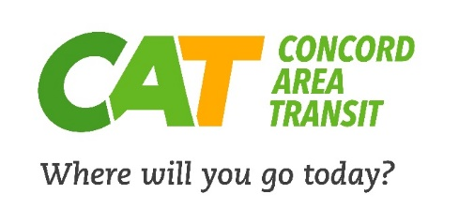
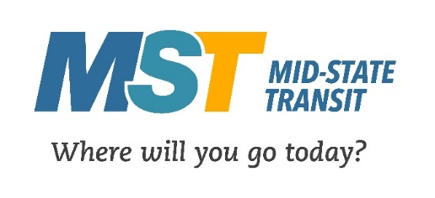
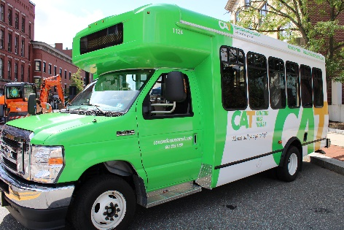
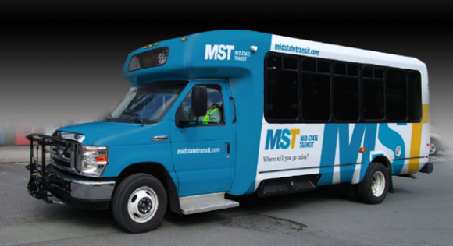

DHHS Heath Disparities Grant
Region 3 was one of the 5 of the rural regions in NH that received a grant award in FY22. The projects supported by this grant are listed.
- Driver retention differential pay.
At the onset of the pandemic, CAPBM lost several employees and others expressed concern about continuing employment as a “front-line employee.” CARES funds provided differential pay during the pandemic, which proved extremely helpful in retaining staff. Hourly labor rates have increased significantly leaving our driver pay rates below par making it exceedingly difficult to compete with other driver opportunities. This funding will be used to enhance transportation staff wages at CAPBM and Granite State Independent Living with the objective of retaining staff. Once these funds were exhausted, CAPBM secured a permanent driver wage increase.
- Transit Passenger Technology Enhancements
Original Request and scope: Today’s public transit riders and potential riders are looking for technology enhancements when using public transit services such as “find my bus” and infotainment systems. In addition to real-time bus location and auto-generated stop announcements, this system will also allow essential information to be shared with the public via tv-type screens on the buses. Rapidly changing information, such as we witnessed throughout the pandemic, can be updated immediately reaching the population faster and in real-time.
- Enhance existing rideshare software.
Original Request and scope: In partnership with NH’s planning commissions, NH through CommuteSmartSeacoast and CommunteSmartNH, invested in ridesharing matching and reward software tool to encourage “greener” commuting through rewards. It provides one online location for transportation resources for commuters or other professionals working with vulnerable populations, to find alternative transportation options such as public transportation, bike paths, car and van pools, EV station locations, park and rides, and tips for working from home and more. Many lost their jobs due to the pandemic and are looking for employment. This software is one more tool in the toolbox to assist not only commuters but anyone, including vulnerable populations, find transportation options. This funding will allow additional flexibility to the tools offered, improvements to the site and\or extended access to the tools.
- Radio, print & TV ads.
Original request and scope: This funding will be used to help us reach Region 3’s most vulnerable populations through advertising.
- Elimination of Bus Fares
Original request and scope: We eliminated bus fares at the beginning of the pandemic allowing more separation between drivers and passengers. This proved beneficial as we did not have any outbreaks among staff or ridership that were related back to the buses. Fare-free transportation will allow continued distancing keeping our drivers safe from hand-to-hand contact with riders. In addition, this removes the cost barrier to transportation for those financially impacted by the pandemic. All CAPBM transportation services remain fare-free.

Volunteer Driver Program:
This program has a part-time coordinator, funded through Section 5310 funds. Drivers received training on Defensive Driving, and how to utilize scheduling software to effectively match available drivers with those needing rides. Since the program started in late 2011, the volunteer driver program has provided over 50,000 rides to medical appointments. Ridership for the last three years is as follows:
Volunteer Driver Program | # of one-way Trips | # of Paratransit VDP trips
2021 | 3321 | 111
2022 | 2285 | 121
2023 | 1787 | 54

Mobility Manager:
Mid-State RCC continues to support the regional Mobility Manager position. The Mobility Manager is a key part of the coordination and community outreach efforts by Mid-State RCC. Utilizing and supporting a regional mobility manager has been a priority for the Mid-State RCC Region 3 for years and is listed specifically in the most recent Regional Coordinated Transportation Plan (2019); Goals 1, 3 and 4. It is also recommended in the 2016 NH Statewide Coordination of Community Transportation Service Plan Final Report published January 2017, pg. 100-102. In FY22, the Statewide Coordinating Council for Community Transportation established the statewide Mobility Management Network.
Mobility management is a transportation strategy that prioritizes customer needs, and the meeting of these needs through the coordinated use of a variety of providers.
Example of the positive impact a mobility manager can have in a region is showcased in the following example: At the onset of NH’s Stay at Home order during the COVID-19 pandemic, the mobility manger was able to execute a “Shopping For Seniors” program using volunteer shoppers and senior transit buses to bring groceries to public transportation dependent senior & disabled riders, allowing this most vulnerable population to stay safely at home. This program ran April 1 – June 30, 2020.
With the advent of the statewide Mobility Manager Network in FY22, the VDP Peer-to-Peer Network expanded to include all the VDPs across the state and continues to meet quarterly.
The Mobility Manager maintains the Mid-State RCC website at www.midstatercc.org, and its Facebook page. Concord Area Transit’s website is www.ConcordAreaTransit.com and its Facebook page at https://www.facebook.com/concordareatransit.
Mid-State Transit Program:
Mid-State Transit (fka Rural Transportation Service) is Region 3’s fully assessable demand response transit system providing transit service to residents 60 years of age or older and adults with disabilities under the age of 60. Before moving this service to the transportation services program, this service was run out of the 5 CAPCM senior centers. Transportation Services took responsibility for this program at the end of calendar year 2019 to improve efficiency and expand transit access. Since taking over this program, MST has provided more than 60,000 trips. The service saw a 46% increase in trips from FY21 to FY22 and a 32% increase from FY22 to FY23. The program continues to grow ridership year after year. FY 2023 saw trip numbers at a 5-year high and so far, FY24 is looking like it will surpass the FY23 numbers.
MST | # of Trips
2021 | 8352
2022 | 12185
2023 | 16073

Taxi Voucher Program:
In July 2016 Mid-State RCC launched a pilot Taxi Voucher program for the Merrimack County Department of Corrections (MCDOC) Successful Offender Adjustment and Reentry (SOAR) Program. The intent of the MCDOC SOAR is to provide support during this period so that individuals who are 60 years and older or with disabilities can successfully complete the program and reintegrate into society. Without transportation, individuals remain disconnected from society, which forces them to return to MCDOC after release for failing to meet the programs expectations. Starting in FY22, the Taxi Voucher Program expanded the program to include Merrimack County Human Services allowing clients of the County Navigators program and MC Mental Health Court access to the taxi services. TVP provided 263 taxi rides in FY 2021, 286 taxi rides in FY 2022 and 57 rides in FY 2023.
Taxi Voucher Program | # of Trips
2021 | 263
2022 | 286
2023 | 57

Current RCC Membership
Vincent Pagano, Central NH Regional Planning Commission
Terri Paige, Vice-chair, Community Action Program Belknap-Merrimack Counties, Inc.
Toni Marshall, Concord Cab Company, LLC
Frank Caron, Department of Corrections, Merrimack County
Roger Vachon, EngAgingNH
Laura Rundell, Friends Program-RSVP
Susanne Peace, Future in Sight (fka NH Association for Blind)
Travis Colby, Lakes Region Mental Health Center
Carrie Chandler, Helping Hands of the Lakes Region, and Wesley Woods Senior Living
Derek Lavoy, Granite State Independent Living
TBD, Interlakes Community Caregivers, Inc.
Rebecca Bryant, Lakes Region Community Services
Sean Chamberlain, Lakes Region Planning Commission
Jessica Riendeau, Merrimack County Human Services
Tammy Carmichael, Partnership for Public Health
Jane Alden, Town of Tilton
Tom Schamberg, Chair, Town of Wilmot
Andrew Harmon, Resident of New Hampton
Regional Mobility Manager:
Cindy Yanski (CAPBM)

